# **Getting Started:-**

**Angular Learn :-**

Maximilian Schwarzmuller  (  Academind.com )

**Introduction Angular:-**

Angular Is a **java script  Framework** which allows you to create reactive **Single-Page-Application(SPAs).**

**Difference Beeween Angular js And Angular:-**

Anglar Js Is first Realese version And angular is framework is after the mazor changes of first version (2nd to 16th ) till date.

**Install Angular:-**

1. **npm Install -g Angular/CLI@latest**

2. **npm Install -g Typescript**

3.**Create New App:-**

**Ng new my-first-app --no-strict** ( Strict are special mode than are used to optimized project.)

4.**Start The Srver :-**

The star the angular app we used the **npm start or ng serve**.

5.**Course Structure:-**

This Is Course Structure than Apply through This Course:-

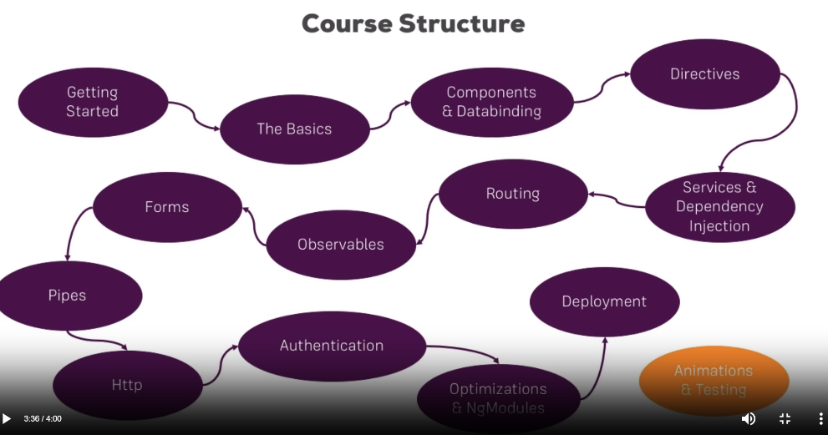

**6.Type Script:-**

Type Script Is Advancce Feature Of Vanila Js.

In type script we can defined a variable, class and Internface.

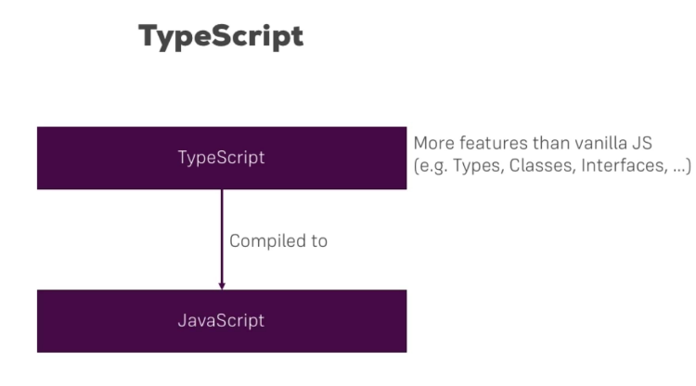

**7.Boostrap:-**

**1.Install Boostrap:-**

npm i bootstrap@5.3.0-alpha3

**2. Add a path of boostrap in package.json:-**

Add A path in package.json is like this :- node_module => boostarp => dis => css => boostarp.min.css

# **Basic:-**

**Structure Of TS File :-**

IN **Ts File** we can add a component and link of module and module both.

**@NgMODULE**({ => can describe as a file ca specified in .ts file inside the component.

**Declarations** => the file can declare the component.

**Imports** => the module can specified here.

Providers => can specified the services.

Bootstrap => can specified the app component.

})

**\*\*Angular in the end is JS framework, changing DOM (“HTML”) at runtime!\*\***

**Introduction to Module And Components:-**

**Component:-** component are used for the particular part can represent the part of site.

* Components are the add a component path in module folder.
* And add a import file in generate module component.
* Add in declaration directors.
* <app-directive> add in app.html file

**Generate Compobnent:-** ng generate component component name. (**ng g c name**).

**Module:-**Module can represent the all of the app in one module .

**Data Binding;-** Data binding is bind the data between the html and ts file.

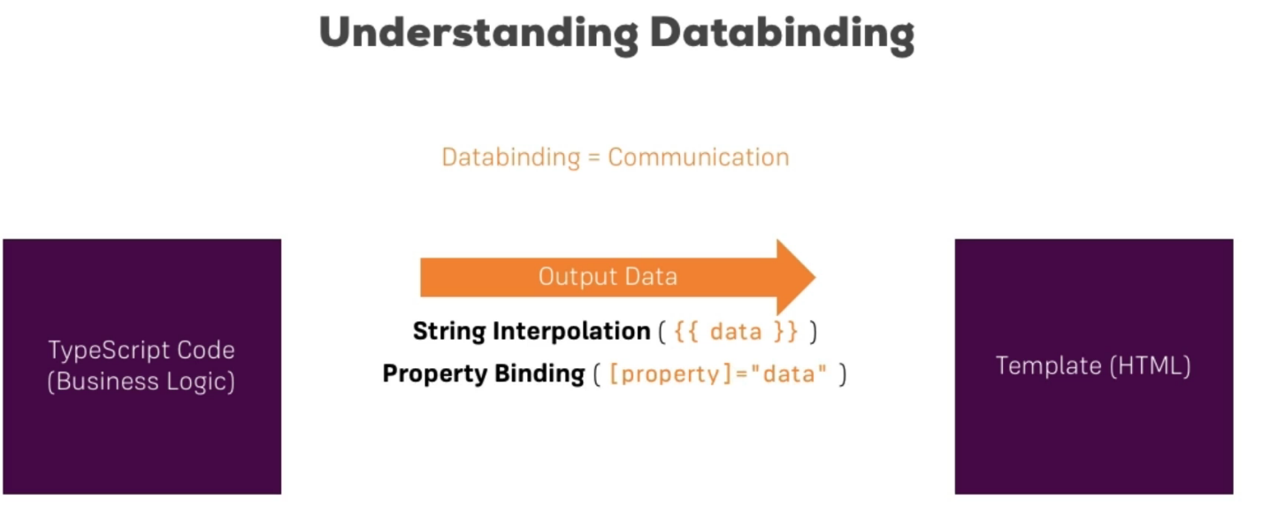

* String interpolation are in html file And Property Binding are used in ts file.

**String Interpolation:-**

* In the String Interpolation end of make the string so that the start of the name make in string like => {{‘name’}}.
* At the end of the line we can not afford the multiline code so that the we add interpolation at the start.